**Task 5**

**No Monster World**

**Team Members: Sayed Md Abu, Siyu Deng, Ige Tosin O**

In this task, we would like our character makes monster disappear within current map if we input “disappear” in the dialogue and hit enter. Once our character processed to another map and head back, the not killed disappeared monster will show up again.

**Before Cheat**

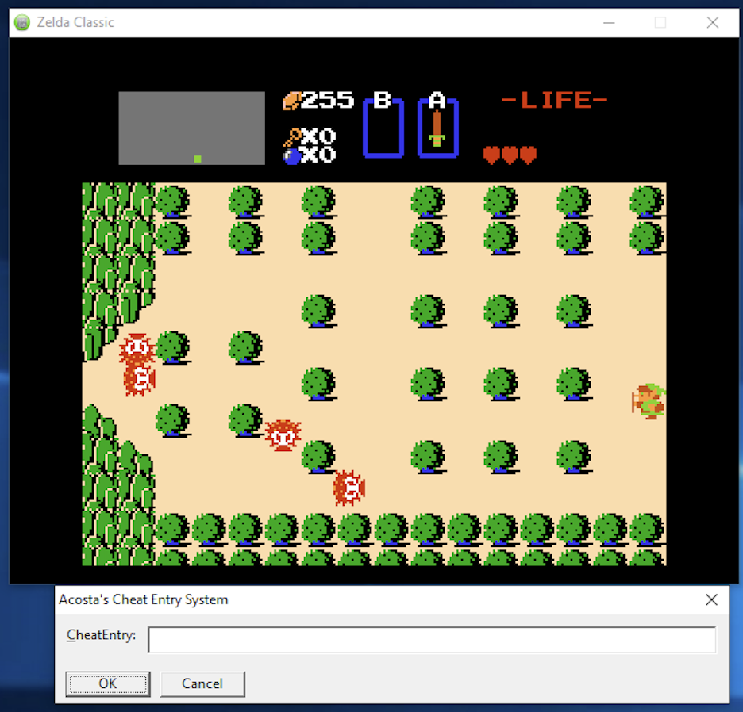

**After Cheat**

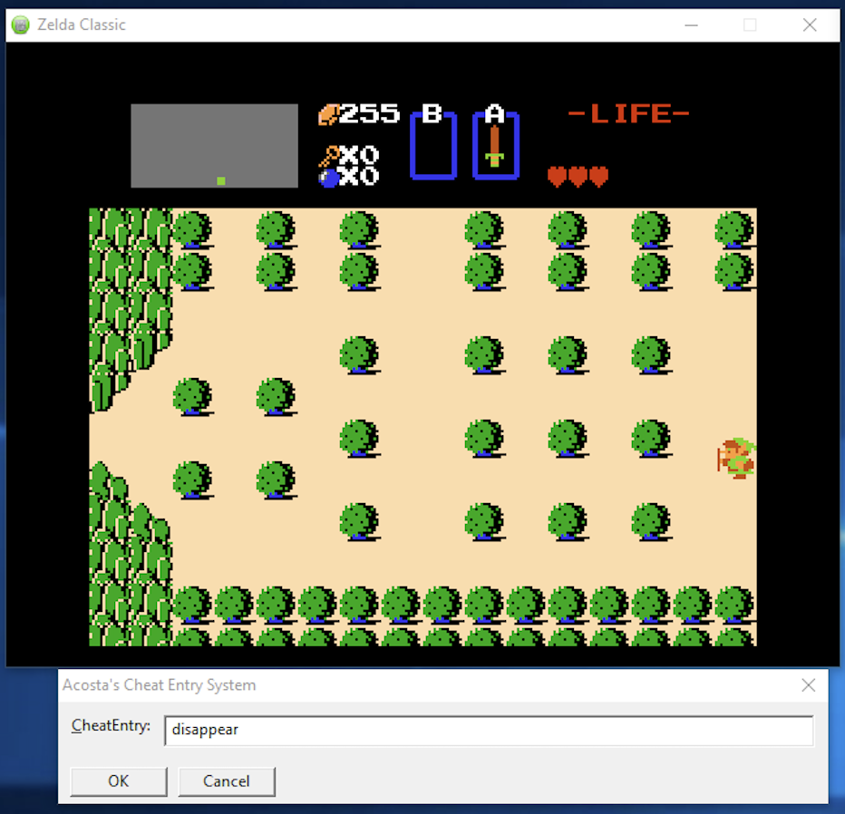

**Go to another map and head back**

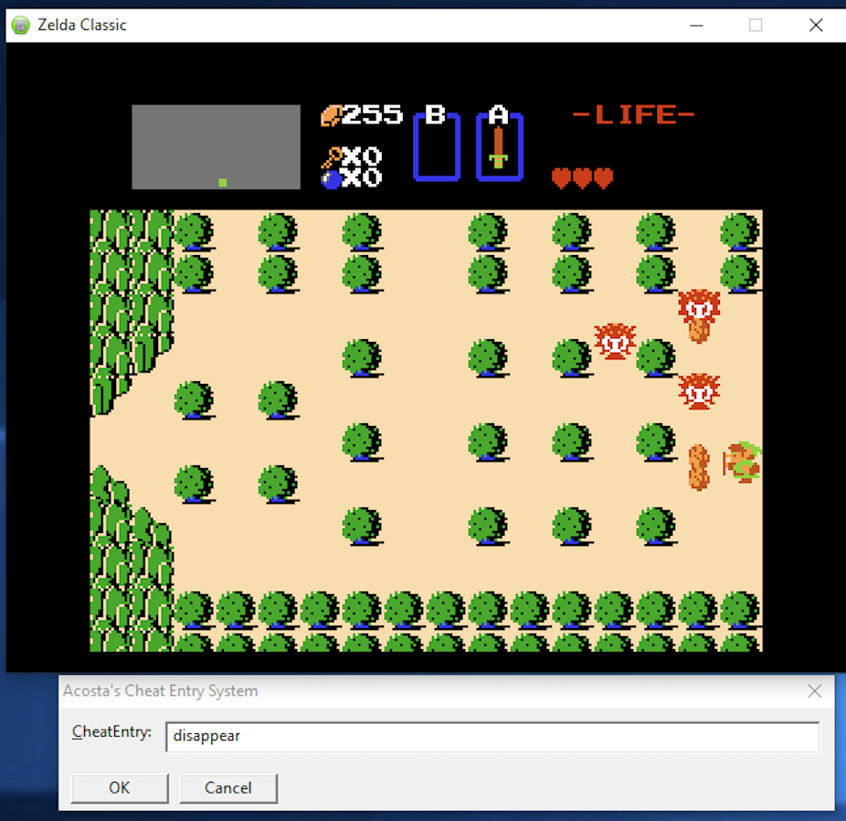

We accomplish this by directly modify the value contained within the memory address which keeps the number of enemies. Since this address is fixed, we do not have to modify instructions as previous tasks. Instead, we can directly overwrite the value within that address.

Address which holds number of enemies are shown on screen: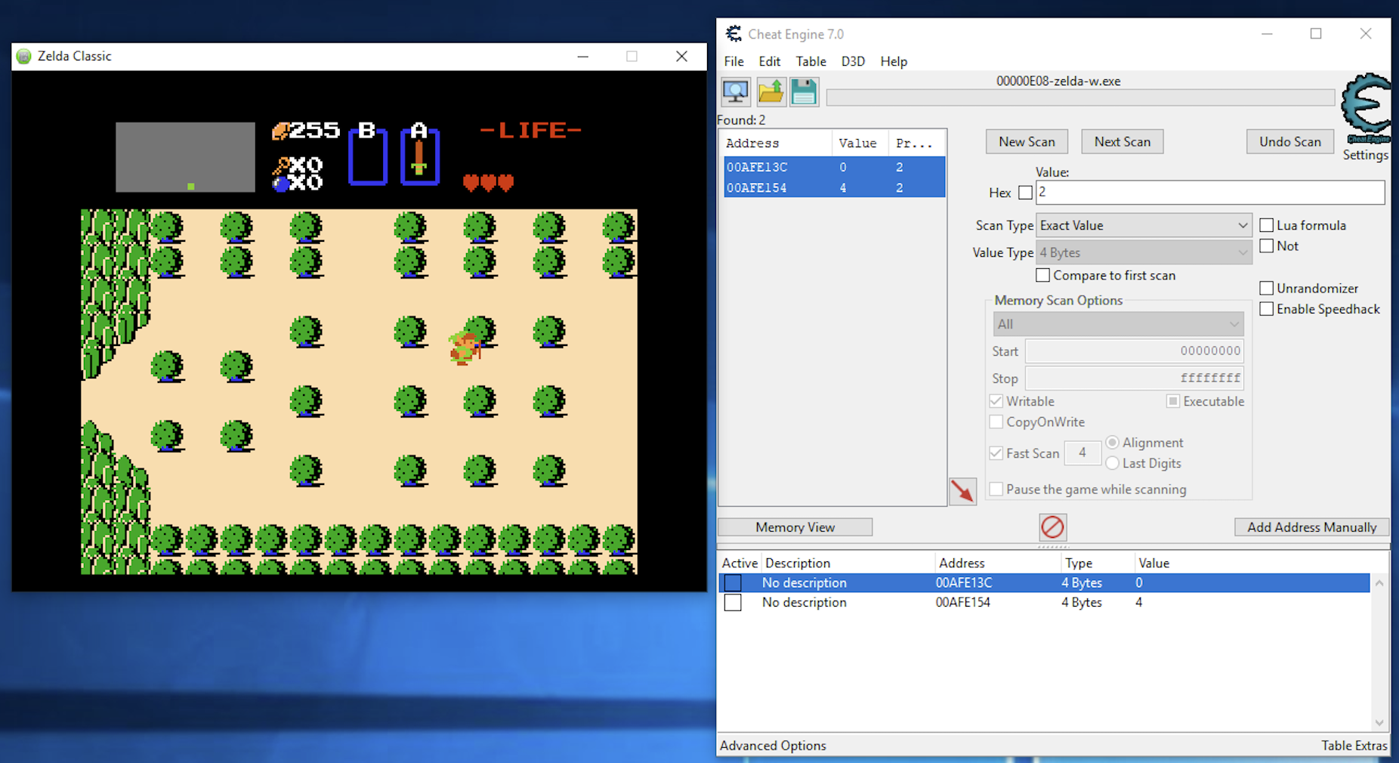

Note, there are two associated address. But after several experiments, we find that the upper address that holds the value that we want.

Then, we use the similar approach like previous tasks that overwrites this memory address with “x00,x00,x00,x00”.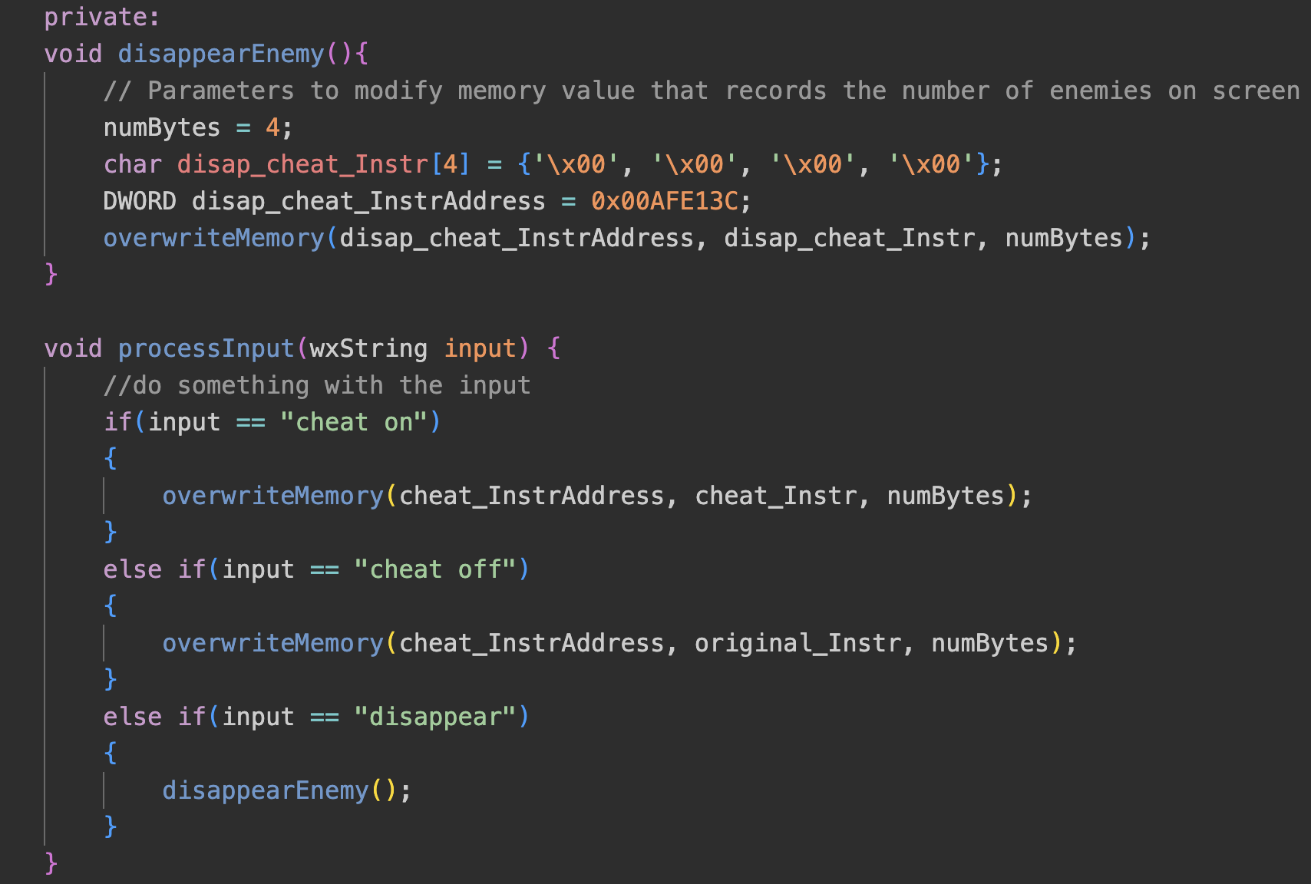

As shown before, this functionality is enabled by inputing “disappear” into the dialog box.

Injectee.cpp is stored at **./Injectee/Injectee.cpp**.